# **Supplementary material**

# **Methods**

## Software

Data handling and analysis was accomplished with R version 4.2.3. For general transformation tasks for matrix, tabular, and text data, base R, *tidyverse* package bundle (1), *rlang* (2), [*trafo*](https://github.com/PiotrTymoszuk/trafo), and *stringi* (3) were utilized. General data visualization tasks were performed with *ggplot2* (4), *cowplot* (5), and *flextable* (6).

## Data sources

Five collectives of urothelial carcinoma patients were evaluated in the current report: the urothelial cancer subset of the GENIE cohort referred to as GENIE BLCA (7), the MSK IMPACT collective (8), the bladder cancer TCGA collective of muscle-invasive urothelial cancers referred to as TCGA BLCA (9,10), the IMvigor cohort of chemotherapy-resistant cancers treated subsequently with immunotherapy (11), and the BCAN cohort of metastatic cancer patients administered systemic chemotherapy (12).

The GENIE BLCA cohort (7) includes n = 3164 cases of bladder and urinary tract cancers selected by oncotree classification ‘BLAD’, ‘BLCA’, ‘BLSC’, ‘UA’, ‘UAD’, ‘UCA’, ‘UCU’, ‘UPA’, ‘URCA’, ‘USCC’, or ‘UTUC’. The available data sets for the GENIE BLCA cohort included basic clinical information (age at sequencing in years, sex, follow-up in days, mortality), total mutation burden (TMB) expressed as fraction of genome, detailed information on location, variant type, nucleotide sequence and protein residues affected by somatic mutations, as well as 0/1 coded absence/presence of gene deletions and amplifications. Approximate overall survival was computed as the time interval between the last follow-up in days and age at sequencing in years. In case of multiple samples per participant, the earliest sample, i.e. the specimen with the lowest ID, was included in the current analysis. The GENIE BLCA data sets were fetched from the [cBioportal API](https://www.cbioportal.org/) with tools provided by the *cbioportalR* package (13) and formatted with in-house developed R scripts.

The MSK IMPACT collective consisted of n = 906 patients with predominantly muscle-invasive urothelial cancers (8).   
In case of multiple samples available for a patient, the sample with the lowest ID was included in the analysis. The clinical information included entries on participants age, gender, overall survival, cancer pathological stage, and cancer treatment. The mutation data set included detailed information on mutation nucleotide sequence, variant type, and affected protein residues. The copy number variant data were provided in 0/1 coded presence of gene deletions and amplifications. The data sets for the MSK impact study were downloaded from [cBioportal](https://www.cbioportal.org/) and implemented in R with in-house developed scripts.

Data sets for the TCGA BLCA cohort (9) was fetched from the [cBioportal](https://www.cbioportal.org/) repository with in-house developed scripts for n = 402 predominantly muscle-invasive urothelial cancer patients. The clinical information consisted of demographic variables (e.g. age, sex, BMI, smoking history), pathological features (e.g. pathological staging, histology, grade, extracapsular extension), survival information (overall, tumor-specific and relapse-free survival), and TMB expressed as mutation count per MB. The somatic mutation data set included detailed information on location, variant type, nucleotide sequence and affected protein residues. The copy number variant data set consisted of 0/1 coded presence of gene amplifications and deletions. The expression data set for the TCGA BLCA collective consisted of $log_{2}\left(x+1\right)$-transformed RSEM-normalized gene-integrated transcript counts obtained by bulk cancer RNA sequencing.

The IMvigor data set included a subset of 179 bladder and ureter muscle non-invasive and muscle-invasive cancers of the IMvigor 210 trial subjected to RNAseq and DNA sequencing (11,14). The study participants were treated with an anti-PD-L1 drug (atezolizumab) following platinum chemotherapy. The clinical data set included basic demographic, clinical and pathological features, best overall response (complete/partial response [CR/PR], stable/progressive disease [SD/PD]), overall survival, and TMB quantified as mutation count per MB. The mutation data set consisted of 0/1 coded basic information on presence of any somatic mutations in a particular gene. The expression data set consisted of $log_{2}\left(x+1\right)$-transformed gene-integrated transcript counts obtained by bulk cancer RNA sequencing. The IMvigor data sets were obtained from the R package *IMvigor210CoreBiologies*.

The BCAN study information was extracted from [cBioportal](https://www.cbioportal.org/) and consisted of demographic and clinical information, staging of primary tumors, overall and disease-specific survival, RNA sequencing expression Z scores of bulk cancer samples, as well as detailed somatic mutation data of bulk cancer specimens. This collective consisted of metastatic cancers, treated in most patients by systemic chemotherapy. The biological material was collected both in urogenital tract and at distant metastatic sites.

For molecular subset assignment and machine learning modeling tasks, $log_{2}$-transformed gene expression levels were processed by ComBat (R package *sva* and [*htGLMNET*](https://github.com/PiotrTymoszuk/htGLMNET)) (15) to correct for the inter-cohort variability.

Assignment of the TCGA BLCA, IMvigor, and BCAN cancer samples to consensus molecular classes was done with the nearest centroid algorithm fed with ComBat-normalized whole-genome log_2 mRNA or Z-score expression levels (R package *consensusMIBC*) (16).

The following genes coding for FGF, FGFR and FGFBP (FGF-binding proteins) were investigated in the current report (17-28):

* **FGF genes:** *FGF1*, *FGF2*, *FGF3*, *FGF4*, *FGF5*, *FGF6*, *FGF7*, *FGF8*, *FGF9*, *FGF10*, *FGF11*, *FGF12*, *FGF13*, *FGF14*, *FGF17*, *FGF18*, *FGF19*, *FGF20*, *FGF21*, *FGF22*, and *FGF23*
* **FGFR genes:** *FGFR1*, *FGFR2*, *FGFR3*, *FGFR4*, *FGFRL1*, and *TGFBR3*
* **FGFBP genes**: *FGFBP1*, *FGFBP2*, *FGFBP3*, *KL*, *KLB*, *PTX3*, *SDC1*, *SDC2*, *SDC4*, *DCN*, *CD44*, *HSPG2*, *GPC1*, *GPC3*, *GPC4*, *TNFAIP6*, *FIBP*, and *ANOS1*

Those genes were returned by a systematic search of literature at [PubMed](https://pubmed.ncbi.nlm.nih.gov/) as well as a screening of physical interaction partners of FGFR and FGF proteins at [UniProt](https://www.uniprot.org/), [STRING](https://string-db.org), [BioGRID](https://thebiogrid.org), and [IntAct](https://www.ebi.ac.uk/intact).

JSON files with domain structures of FGFR1 (ID: P11362), FGFR2 (ID: P21802), FGFR3 (ID: P22607), and FGFR4 (ID: P22455) proteins were downloaded from [UniProt](https://www.uniprot.org) and processed with the *jsonlite* package (29).

For verification of expression of the FGFR-, FGF-, and FGFBP-coding genes at protein level, we resorted to the [Human Protein Atlas (HPA) repository](https://www.proteinatlas.org/), which stores results of immunohistochemical (IHC) staining. Entries of the HPA database were retrieved as XML documents, from which patient information, staining quantification, and URLs to IHC images for the genes of interest was retrieved (R package *xml2*) (30). Protein expression in the IHC samples was expressed as the IHC score defined as a product of staining (1: negative to 4: high), staining intensity (1: negative to 4: strong), and quantity of positive cells (1: none to 4: >75%).

Mutation status, baseline expression measured by RNA sequencing in urothelial cancer cell lines were downloaded from the [DepMap](https://depmap.org/portal/) repository (31). The available cell lines were 253J (ID:ACH-000011), T24 (ID:ACH-000018), 253J-BV (ID:ACH-000026), SLR 20 (ID:ACH-000127), CAL-29 (ID:ACH-000142), RT4 (ID:ACH-000242), SW 780 (ID:ACH-000384), J82 (ID:ACH-000396), RT-112 (ID:ACH-000473), KU-19-19 (ID:ACH-000486), UM-UC-3 (ID:ACH-000522), VM-CUB1 (ID:ACH-000545), HT-1197 (ID:ACH-000547), SW-1710 (ID:ACH-000566), BC-3C (ID:ACH-000593), TCCSUP (ID:ACH-000720), HT-1376 (ID:ACH-000724), U-BLC1 (ID:ACH-000741), JMSU-1 (ID:ACH-000753), BFTC-905 (ID:ACH-000802), UM-UC-1 (ID:ACH-000834), SCaBER (ID:ACH-000839), KMBC-2 (ID:ACH-000862), 647-V (ID:ACH-000896), 5637 (ID:ACH-000905), 639-V (ID:ACH-000973), RT112/84 (ID:ACH-001183), UM-UC-13 (ID:ACH-001407), UM-UC-14 (ID:ACH-001408), UM-UC-16 (ID:ACH-001409), UM-UC-4 (ID:ACH-001410), UM-UC-5 (ID:ACH-001411), UM-UC-10 (ID:ACH-001412), UM-UC-11 (ID:ACH-001413), UM-UC-6 (ID:ACH-001414), UM-UC7 (ID:ACH-001415), UM-UC9 (ID:ACH-001416), DSH1 (ID:ACH-002235), and LB831-BLC (ID:ACH-002266). The mutation status was 0/1 coded, where 1 stood for presence of at least one somatic mutation in a gene. RNA sequencing information was provided as $log_{2}$ TPM. The copy number-corrected effect scores of CRISPR/Cas9 knockouts and RNA inference were computed by Demeter2 and CHRONOS algorithms (32,33). Gene effects of the knockouts and RNA interference for the FGFR receptor genes were compared with the background effects for non-expressed genes (95th percentile of expression values = 0; CRISPR/Cas9: n = 586), RNAi: n = 364 non-expressed genes). Significant gene effects were considered for effect scores beyond the 95th percentile range of the non-expressed background effects. Resistance of urothelial cancer cell lines to pan-FGFR inhibitors and doxorubicin considered as a positive control was assessed for urothelial cancer cell lines in the GDSC1/2 (compounds: doxorubicin, PD173074, AZD4547, and FGFR_3831, source [GDSC data portal](https://www.cancerrxgene.org/)) and PRISM experiments (compounds: doxorubicin, AZD4547, LY2874455, and erdafitinib, source: [DepMap](https://depmap.org/portal/)) (34,35). The resistance was measured in the GDSC1/2 experiments by IC50, the concentration resulting in 50% growth inhibition; sensitive cell lines were defined by IC50 < 10 µM, which was the highest concentration of the FGFR inhibitors in the assays. The resistance in the PRISM assays was gauged by AUC, i.e. area under the dose-response curve normalized for effects of DMSO control; sensitive cell lines were considered for AUC < 1.

## **Descriptive statistics, statistical inference, and effect size**

If not indicated otherwise, descriptive statistics for quantitative variables included median, interquartile range, and range. Descriptive statistic for qualitative variables were percentage and count within categories. Differences of means or medians of qualitative variables were investigated by Mann-Whitney, two-tailed T test, Kruskal-Wallis test, and one-way ANOVA, depending on the number of analysis groups and normality of distribution of the variable. Correlation was assessed by Pearson’s correlation test. Effect size of differences in variable levels, distribution, and correlation was assessed with the following statistics (36):

* biserial r for differences between two groups, non-parametric tests: small for r < 0.2, medium for 0.2 $≤$ r < 0.4, large for r $≥$ 0.4
* Cohen’s d for differences between two groups, parametric tests: small for d < 0.5, medium for 0.5 $≤$ d < 0.8, large for d $≥$ 0.8
* $η^{2}$ for differences between three or more groups: small for $η^{2}$ < 0.06, moderate for 0.06 $≤$ $η^{2}$ < 0.14, large for $η^{2}≥$ 0.14
* Cramer’s V for comparison of category frequencies of a numeric variable: small for V < 0.2, medium for 0.2 $≤$ V < 0.4, large for V $≥$ 0.4
* Pearson’s r for correlation, parametric tests: small for r < 0.3, medium for 0.3 $≤$ r < 0.5, large for r $≥$ 0.5
* Spearman’s $ρ$ for correlation, non-parametric tests: small for $ρ$ < 0.3, medium for 0.3 $≤$ $ρ$ < 0.5, large for $ρ$ $≥$ 0.5

Hypothesis testing results were adjusted for multiple comparisons separately for each analysis step and investigated cohort with the false discovery rate method (FDR) (37). Differences with p < 0.05 were considered statistically significant. Statistical hypothesis testing was accomplished with the development packages [*fastTest*](https://github.com/PiotrTymoszuk/fastTest) and [*ExDA*](https://github.com/PiotrTymoszuk/ExDA) which partly employ statistical tools of base R, *stats*, *rstatix*, and *rcompanion* (38,39).

## **Differences in rates of genetic alterations**

Differences in rates of genetic alterations between analysis groups of interest were investigated either by $χ^{2}$ test with Cramer’s V effect size metric (package [*fastTest*](https://github.com/PiotrTymoszuk/fastTest)) or by weighted permutation test (package [*perich*](https://github.com/PiotrTymoszuk/perich)). In the later case, the actual frequency of a genetic alteration was compared with the expected frequency obtained in n = 1000 - 10000 permutations weighted by counts of all genetic alterations in the cancer samples. This testing procedure yielded an effect size statistic called enrichment score (ES) defined as the ratio of the actual to the expected genetic alteration number in an analysis group. By iterating over the permutations, 95% confidence intervals of ES and p values for the ES $≤$ 0 null hypothesis were computed.

## **Differential gene expression**

Differences in $log_{2}$-transformed expression levels of FGF-, FGFR-, and FGFBP-coding genes between cancers with and without *FGFR3* mutations were assessed by Welch’s two-tailed T test with Cohen’s d effect size statistic (function f_t_test(), package [*fastTest*](https://github.com/PiotrTymoszuk/fastTest)). The differentially expressed genes were identified by FDR-corrected p < 0.05 and at least 1.25-fold up- or downregulation as compared with WT tumors.

Differences in $log_{2}$-transformed transcript levels of the genes of interest between consensus molecular classes or genetic subsets of urothelial cancers were explored with a two-step procedure. In the first step, differences of expression levels between the analysis groups were assessed by one-way ANOVA with $η^{2}$ effect size statistic. In the second step, differences between an analysis class and the baseline (luminal papillary cancers for the consensus classes, del9p21 subset for the genetic subsets) were evaluated by Welch’s two-tailed T test with Cohen’s d effect size. The significantly differentially regulated genes were defined by pFDR(ANOVA) < 0.05, $η^{2}≥$ 0.06, pFDR(T test) < 0.05, and at least 1.25-fold up- or downregulation as compared with the baseline.

In the differential expression analyses, functions f_one_anova() and f_t_test() from [*fastTest*](https://github.com/PiotrTymoszuk/fastTest) package were used.

## **Co-occurrence of genetic features**

Co-occurrence analysis was performed in two settings: (1) for the most common genetic features (mutations, amplifications, deletions) present in at least 5% of cancer samples in all cohorts and (16) for all available mutations, amplifications, and deletions of FGF- and FGFR-coding genes. Co-occurrence of genetic features was investigated by Jaccard’s similarity coefficient J and Jaccard’s distance computed with the $D=1-J$ formula. Significance of co-occurrence, i.e. $J>0$ , was assessed by bootstrap test with B = 10000 iterations. Mutual co-occurrence (e.g. between *FGFR3* mutations and *RB1* mutations) was depicted as a heat map of contingency table.

For visualization of co-occurrence of multiple genetic features in two-dimensional Euclidean space, matrices of pairwise Jaccard’s distances were subjected to multi-dimensional scaling (MDS). Subsequently, the genetic features of interest were displayed in scatter plots with point size corresponding to the general frequency of the genetic alteration.

Co-occurrence analysis was done with [*clustTools*](https://github.com/PiotrTymoszuk/clustTools) and *jaccard* R packages (40).

## **Gene-co-regulation networks**

Co-expression networks of the FGF-, FGFR-, and FGFBP-coding genes were constructed in form of weighted graphs for pairwise correlations of the expression levels with Spearman’s $ρ≥$ 0.3 (function as_iGraph(), package [*graphExtra*](https://github.com/PiotrTymoszuk/graphExtra) with wrapper tools for *igraph*) (35). Isolated vertices were removed with prune_degree() function. The following vertex importance statistics (41) were computed with summary() method called for the network objects: degree (number of directly connected neighbor nodes), hub score (eigenvector of the affinity matrix, i.e. an overall strength of correlations), and betweenness (number of the shortest paths between all pairs of vertices that pass through the vertex). The networks were visualized with Fruchterman - Reingold algorithm by calling plot() method (42).

## **Machine learning modeling of consensus molecular subsets of urothelial cancers with expression of FGFR-, FGF-, and FGFBP-coding genes as explanatory factors**

To check if and how differences in expression of the FGFR-, FGF-, and FGFBP-coding genes of interest emulate the consensus molecular classification proposed by Kamoun and colleagues (16), we resorted to machine learning modeling with two independent algorithms, multinomial regularized Elastic Net regression (43,44) and Random Forest tree ensemble (45,46).

The models were developed in a data set derived from the TCGA BLCA collective; the consensus molecular class assignment by the nearest centroid classifier of *consensusMIBC* R package served as the modeling response. ComBat-processed $log_{2}$ expression levels of the genes of interest were used as the sole explanatory factors. In order to improve recognition of the minority consensus classes, the LumU (luminal unstable) and Stroma-rich subsets, we amplified their observations by over-sampling with the SMOTE algorithm (function smote(), package *performanceEstimation*) (47-49). The Elastic Net model of consensus molecular classes was optimized (tuned) and trained in the SMOTE-amplified training data set with a wrapper around functions cv.glmnet() and glmnet() from *glmnet* package (43). The optimal values of the regularization parameter $λ$ = 0.00377 was found by minimizing the Elastic Net model’s deviance in 200 repeats 10-fold cross-validation. The Random Forest model of consensus molecular subsets was tuned and trained inn the SMOTE-amplified training data set with a wrapper around ranger() function from *ranger* package (45). The optimal set of parameters that control behavior of the Random Forest model, mtry = 5 (number of randomly chosen variables per tree learner), minimal node size = 1, and Gini splitting rule was found by minimizing the out-of-bag classification error (46). The final Random Forest model was an ensemble of 500 tree learners.

Performance of the machine learning models was evaluated by comparing the predicted and actual consensus molecular class in the unmodified TCGA BLCA data set, as well as in the IMvigor and BCAN independent validation cohorts. The consensus classification returned by the *consensusMIBC* R package nearest centroid tool was assumed the ground truth. The following numeric statistics of model performance were computed: overall accuracy (fraction of cancer samples with correct consensus molecular class prediction), Cohen’s $κ$ (non-accidental concordance between the predicted and actual class, high $κ$ expected for a highly accurate model) (50), Brier score (metric of overall model calibration, low Brier scores expected for a well calibrated model) (51-52), and receiver-operating characteristic measures such as area under the curve (AUC, measure of overall sensitivity and specificity). Those evaluation metrics were computed with multiClassSummary() function from *caret* package (53) and an in-house developed function that calculates Brier scores for the models of interest and a nonsense model predicting the classes at random. Additionally, accuracy of prediction for single consensus molecular classes was assessed by inspection of the confusion matrices.

Calibration of the machine learning models at predictions of particular consensus molecular classes was assessed with two approaches. First, we compared squares of differences between the predicted class assignment probabilities and the binarized actual class assignment (1: the class of interest, 0: any other consensus molecular class) or ‘Brier squares’ between the consensus molecular classes. Second, we modeled and visualized logistic relationship between the mean predicted class assignment probability and the actual fraction of observations in the class with tools from *CalibrationCurves* R package (54).

For the Elastic Net model, absolute $β$ values of the model coefficients serve as direct variable importance metrics; they were extracted from the model with coef() method. For the Random Forest model, permutation variable importance proposed by Breiman (45) was computed as the difference in out-of-bag classification error of the genuine model and a model with the particular explanatory variable re-shuffled at random (function importance(), package *ranger*).

# **Data and code availability**

Data from publicly available sources were analyzed. The R analysis pipeline is available as a [GitHub repository](https://github.com/PiotrTymoszuk/FGFR-BLCA)

**Supplementary Table 1 -** Characteristic of the investigated cohorts. Numeric features are presented as medians with interquartile ranges and ranges. Qualitative variables are shown as percentages and observation counts of the categories.

| **Variable** | **GENIE BLCA** | **MSK IMPACT** | **TCGA BLCA** | **IMvigor** | **BCAN** | **Significancea** | **Effect sizea** |
| --- | --- | --- | --- | --- | --- | --- | --- |
| Age, years | 69 [IQR: 62 - 76] range: 18 - 89 complete: n = 3159 | 66 [IQR: 58 - 73] range: 28 - 92 complete: n = 906 | 69 [IQR: 60 - 76] range: 34 - 90 complete: n = 402 |  | 67 [IQR: 59 - 73] range: 28 - 85 complete: n = 174 | p < 0.001 | η² = 0.014 |
| Gender | female: 27% (846) male: 73% (2313) complete: n = 3159 | female: 24% (215) male: 76% (690) complete: n = 905 | female: 26% (105) male: 74% (297) complete: n = 402 | female: 23% (41) male: 77% (138) complete: n = 179 | female: 24% (41) male: 76% (132) complete: n = 173 | ns (p = 0.32) | V = 0.031 |
| Tissue | bladder: 82% (2610) non-bladder: 18% (554) complete: n = 3164 | bladder: 98% (888) non-bladder: 2% (18) complete: n = 906 | bladder: 100% (402) non-bladder: 0% (0) complete: n = 402 | bladder: 88% (158) non-bladder: 12% (21) complete: n = 179 | bladder: 74% (129) non-bladder: 26% (45) complete: n = 174 | p < 0.001 | V = 0.22 |
| Invasiveness |  | non-muscle invasive: 6.2% (56) muscle invasive: 94% (850) complete: n = 906 | non-muscle invasive: 1.1% (4) muscle invasive: 99% (366) complete: n = 370 | non-muscle invasive: 0% (0) muscle invasive: 100% (179) complete: n = 179 | non-muscle invasive: 32% (56) muscle invasive: 68% (118) complete: n = 174 |  |  |
| pT stage |  | T1: 6.2% (56) T2: 21% (190) T3: 72% (651) T4: 0.99% (9) T0: 0% (0) Ta: 0% (0) Tis: 0% (0) complete: n = 906 | T1: 0.81% (3) T2: 32% (117) T3: 52% (192) T4: 15% (57) T0: 0.27% (1) Ta: 0% (0) Tis: 0% (0) complete: n = 370 |  | T1: 5.3% (7) T2: 34% (45) T3: 40% (53) T4: 15% (20) T0: 0.76% (1) Ta: 3% (4) Tis: 1.5% (2) complete: n = 132 | p < 0.001 | V = 0.29 |
| pN stage |  |  | N0: 65% (233) N1: 12% (45) N2: 21% (74) N3: 2.2% (8) complete: n = 360 |  | N0: 59% (63) N1: 15% (16) N2: 18% (19) N3: 7.5% (8) complete: n = 106 | ns (p = 0.058) | V = 0.13 |
| pM stage |  |  | M0: 95% (191) M1: 5.4% (11) complete: n = 202 |  | M0: 67% (12) M1: 33% (6) complete: n = 18 | p < 0.001 | V = 0.29 |
| Mutation burden, mutations/MB or fraction of genome | 0.16 [IQR: 0.044 - 0.33] range: 0 - 1 complete: n = 2247 | 9.5 [IQR: 5.5 - 16] range: 0 - 400 complete: n = 906 | 5.8 [IQR: 3.1 - 10] range: 0.033 - 120 complete: n = 402 | 8 [IQR: 5 - 14] range: 0 - 59 complete: n = 177 |  |  |  |
| Best overall response |  |  |  | SD/PD: 73% (115) CR/PR: 27% (42) complete: n = 157 |  |  |  |
| Mortality | 37% (1136) complete: n = 3109 | 30% (276) complete: n = 905 | 44% (177) complete: n = 402 | 64% (114) complete: n = 179 | 43% (75) complete: n = 174 | p < 0.001 | V = 0.13 |
| aNumeric variables: Kruskal-  Wallis test with η² effect size statistic. Categorical variables: χ² test with Cramer V effect size statistic. | | | | | | | |

**Supplementary Table 2 -** FGFR-, FGF-, and FGFBP-coding genes investigated in the current report.

| **Protein type** | **Gene symbol** | **Entrez ID** |
| --- | --- | --- |
| receptors | *FGFR1* | 2260 |
| *FGFR2* | 2263 |
| *FGFR3* | 2261 |
| *FGFR4* | 2264 |
| *FGFRL1* | 53834 |
| *TGFBR3* | 7049 |
| ligands | *FGF1* | 2246 |
| *FGF2* | 2247 |
| *FGF3* | 2248 |
| *FGF4* | 2249 |
| *FGF5* | 2250 |
| *FGF6* | 2251 |
| *FGF7* | 2252 |
| *FGF8* | 2253 |
| *FGF9* | 2254 |
| *FGF10* | 2255 |
| *FGF11* | 2256 |
| *FGF12* | 2257 |
| *FGF13* | 2258 |
| *FGF14* | 2259 |
| *FGF17* | 8822 |
| *FGF18* | 8817 |
| *FGF19* | 9965 |
| *FGF20* | 26281 |
| *FGF21* | 26291 |
| *FGF22* | 27006 |
| *FGF23* | 8074 |
| binding proteins | *FGFBP1* | 9982 |
| *FGFBP2* | 83888 |
| *FGFBP3* | 143282 |
| *KL* | 9365 |
| *KLB* | 152831 |
| *PTX3* | 5806 |
| *SDC1* | 6382 |
| *SDC2* | 6383 |
| *SDC4* | 6385 |
| *DCN* | 1634 |
| *CD44* | 960 |
| *HSPG2* | 3339 |
| *GPC1* | 2817 |
| *GPC3* | 2719 |
| *GPC4* | 2239 |
| *TNFAIP6* | 7130 |
| *FIBP* | 9158 |
| *ANOS1* | 3730 |

**Supplementary Table 3 –** Expression of FGFR-, FGF-, and FGFBP-coding genes at mRNA level was quantified in the TCGA BLCA, IMvigor, and BCAN cohort by RNA sequencing. The mRNA amounts were provided as log2-transformed gene counts (TCGA BLCA and IMvigor) or Z-scores of log2 gene counts (BCAN). Protein expression of the genes of interest was measured in the Human Protein Atlas (HPA) by immunohistochemistry (IHC). The protein amounts are metered by the IHC score defined as a product of staining intensity and quantity of positive cells. Median mRNA and protein amounts with interquartile ranges, ranges, and numbers of cancer samples are listed. The table is available as a supplementary Excel file.

**Supplementary Table 4** – Performance of Elastic Net and Random Forest models of LumP, LUMU, stroma-rich, and BA/Sq consensus molecular classes of urothelial cancers that uses expression of FGFR-, FGF-, and FGFBP-coding genes as the sole explanatory factors. The models were trained in the TCGA BLCA cohort, the gene expression values were ComBat-processed to minimize inter-cohort variability. Minority consensus classes were amplified by the SMOTE algorithm to improve their identification by the model. The models were evaluated in the TCBA BLCA, IMvigor, and BCAN cohorts; the consensus class assignment predicted by a nearest centroid algorithm from consensusMIBC package served as the ground truth. Metrics of model accuracy, calibration, and receiver-operating characteristic are listed.

| **Algorithm** | **Cohort** | **Accuracya** | **Kappab** | **Brier scorec** | **AUCd** | **Mean sensitivityd** | **Mean specificityd** |
| --- | --- | --- | --- | --- | --- | --- | --- |
| Elastic Net | TCGA BLCA | 0.96 | 0.94 | 0.061 | 1.00 | 0.96 | 0.99 |
| IMvigor | 0.78 | 0.70 | 0.320 | 0.94 | 0.75 | 0.93 |
| BCAN | 0.81 | 0.72 | 0.280 | 0.96 | 0.76 | 0.93 |
| Random Forest | TCGA BLCA | 1.00 | 1.00 | 0.026 | 1.00 | 1.00 | 1.00 |
| IMvigor | 0.77 | 0.68 | 0.320 | 0.94 | 0.73 | 0.92 |
| BCAN | 0.79 | 0.70 | 0.310 | 0.96 | 0.76 | 0.93 |
| aFraction of observations correctly assigned to molecular consensus classes. | | | | | | | |
| bCohen's κ. Non-accidental concordance between the actual and predicted molecular class assignment. | | | | | | | |
| cMeasure of overall model calibration. | | | | | | | |
| dReceiver-operating characteristic (ROC). AUC: area under the ROC curve. | | | | | | | |

**Supplementary Table 5 –** *Coefficients of the Elastic Net model of consensus molecular classes of urothelial cancers. The Elastic Net model was developed in the TCGA BLCA cohort with expression values of genes coding for FGFR, FGF, and FGFBP proteins as the sole explanatory factors. Values of beta of the coefficients are listed.*

| **Variable** | **LumP** | **LumU** | **Stroma-rich** | **Ba/Sq** |
| --- | --- | --- | --- | --- |
| *FGF1* | 0 | 0.0197 | -0.237 | 0 |
| *FGF2* | 0.536 | 0 | 0 | -0.252 |
| *FGF5* | 0 | 0 | 0 | 0.121 |
| *FGF7* | -0.377 | -0.149 | 0.443 | 0.0829 |
| *FGF9* | 0.0288 | -0.0267 | 0.0095 | -0.0117 |
| *FGF10* | 0 | -0.205 | 0.461 | 0 |
| *FGF11* | 0 | -0.193 | 0 | 0.202 |
| *FGF12* | 0 | 0.155 | -0.0118 | 0 |
| *FGF13* | 0.198 | 0 | 0 | 0 |
| *FGF14* | -0.0613 | -0.0657 | 0.358 | 0 |
| *FGF17* | 0 | 0.127 | -0.216 | 0 |
| *FGF18* | -0.415 | 0.317 | 0.0118 | 0 |
| *FGF22* | 0.496 | 0 | 0 | -0.1 |
| *FGF23* | 0 | -0.348 | 0 | 0.681 |
| *FGFR1* | -0.327 | 0 | 0.625 | 0 |
| *FGFR2* | -0.249 | 0.223 | -0.0468 | 0.073 |
| *FGFR3* | 0.379 | -0.097 | 0 | -0.247 |
| *FGFR4* | 0 | 0.619 | -0.139 | -0.181 |
| *FGFRL1* | -0.339 | 0.317 | 0.214 | -0.192 |
| *TGFBR3* | 0.612 | 0 | 0 | -0.797 |
| *FGFBP1* | 0.0909 | -0.28 | -0.336 | 0.525 |
| *FGFBP2* | -0.0457 | 0 | 0 | 0.269 |
| *FGFBP3* | 0.341 | 0 | 0.188 | -1.01 |
| *KL* | 0 | 0.117 | 0 | -0.337 |
| *KLB* | 0 | 0 | -0.43 | 0 |
| *PTX3* | -0.174 | 0 | 0 | 0.204 |
| *SDC1* | 0.207 | -0.238 | 0.386 | -0.356 |
| *SDC2* | 0.266 | -0.532 | 0.503 | -0.237 |
| *SDC4* | 0 | 0.107 | -0.145 | 0 |
| *DCN* | -0.245 | 0 | 0.214 | 0 |
| *CD44* | 0 | -0.981 | 0 | 0.562 |
| *HSPG2* | 0 | 0.258 | 0 | -0.076 |
| *GPC1* | 0 | -1.58 | 0 | 0.557 |
| *GPC3* | 0.168 | -0.0242 | 0.00239 | -0.147 |
| *GPC4* | 0.131 | 0 | -0.0519 | 0 |
| *TNFAIP6* | -0.585 | 0 | 0 | 0 |
| *FIBP* | 0 | 0 | 0 | -0.154 |
| *ANOS1* | -0.432 | 0.0179 | -0.0661 | 0.48 |

**Supplementary Table 6 -** Permutation variable importance of the Random Forest model of consensus molecular classes of urothelial cancers. The Random Forest model was developed in the TCGA BLCA cohort with expression values of genes coding for FGFR, FGF, and FGFBP proteins as the sole explanatory factors. Permutation importance was computed as differences of errors of the genuine model and models, in which the explanatory variables were re-shuffled at random*.*

| **Varaible** | **Permutation importance** |
| --- | --- |
| *CD44* | 0.11 |
| *TGFBR3* | 0.079 |
| *DCN* | 0.071 |
| *FGF7* | 0.063 |
| *TNFAIP6* | 0.051 |
| *FGFBP1* | 0.044 |
| *GPC1* | 0.04 |
| *FGFR1* | 0.039 |
| *FGFR3* | 0.027 |
| *FGF5* | 0.024 |
| *FGF14* | 0.022 |
| *FGF10* | 0.021 |
| *FGFBP3* | 0.018 |
| *FGF2* | 0.018 |
| *SDC1* | 0.017 |
| *SDC2* | 0.017 |
| *FGFR4* | 0.017 |
| *FGF18* | 0.015 |
| *KL* | 0.012 |
| *ANOS1* | 0.012 |
| *FGF9* | 0.011 |
| *HSPG2* | 0.011 |
| *PTX3* | 0.0088 |
| *FGF1* | 0.0087 |
| *GPC3* | 0.008 |
| *FGFRL1* | 0.0073 |
| *FGF17* | 0.0058 |
| *FGFR2* | 0.0056 |
| *KLB* | 0.0053 |
| *FGF13* | 0.0047 |
| *GPC4* | 0.0043 |
| *FGFBP2* | 0.0042 |
| *FGF11* | 0.004 |
| *FGF12* | 0.004 |
| *SDC4* | 0.0029 |
| *FIBP* | 0.0021 |
| *FGF22* | 0.0017 |
| *FGF23* | 0.00081 |

**Supplementary Figure 1** – **Alterations of FGFR-, FGF-, and FGFBP-coding genes in consensus molecular classes of urothelial cancers.** Cancer samples from the IMvigor and BCAN data set was assigned to the MIBC consensus molecular subtypes based on ComBat-adjusted whole-genome mRNA levels by the nearest centroid algorithm (R package consensus MIBC). Differences in frequency of somatic mutations and copy number variants of FGFR-, FGF-, and FGFBP-coding genes between the consensus molecular classes were assessed by weighted permutation test. P values were corrected for multiple testing with the false discovery rate method. Note that copy number variant information was not available for the IMvigor cohort. Presence/absence of selected genetic alterations in the consensus molecular classes visualized in oncoplots. Alteration names with effect sizes and p values of differences between the consensus classes are indicated in the Y axis. Significant effects are highlighted with bold font. Numbers of cancer samples in the consensus classes are displayed in the plot captions.

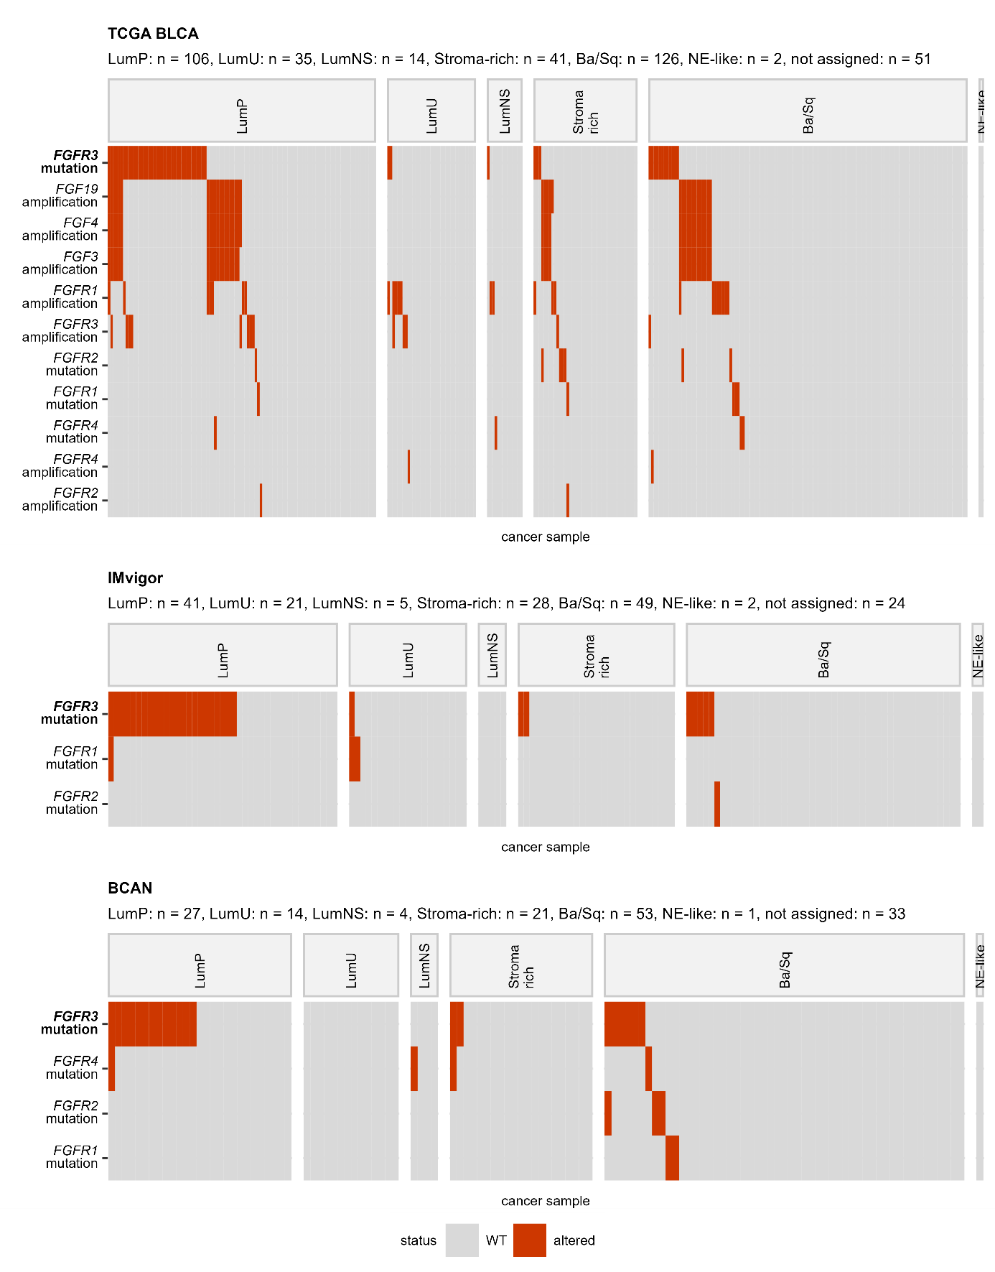

**Supplementary Figure 2** - **Frequency of somatic mutations in FGFR1/2/3/4 genes split by protein domain.** Mutations in FGFR1, FGFR2, FGFR3, and FGFR4 genes in the GENIE BLCA, MSK IMPACT, TCGA BLCA, and BCAN cohorts were classified by protein domain. Their frequency was expressed as percentage of cancer samples and presented in stack plots. Numbers of analyzed cancer samples are displayed in the plot captions.

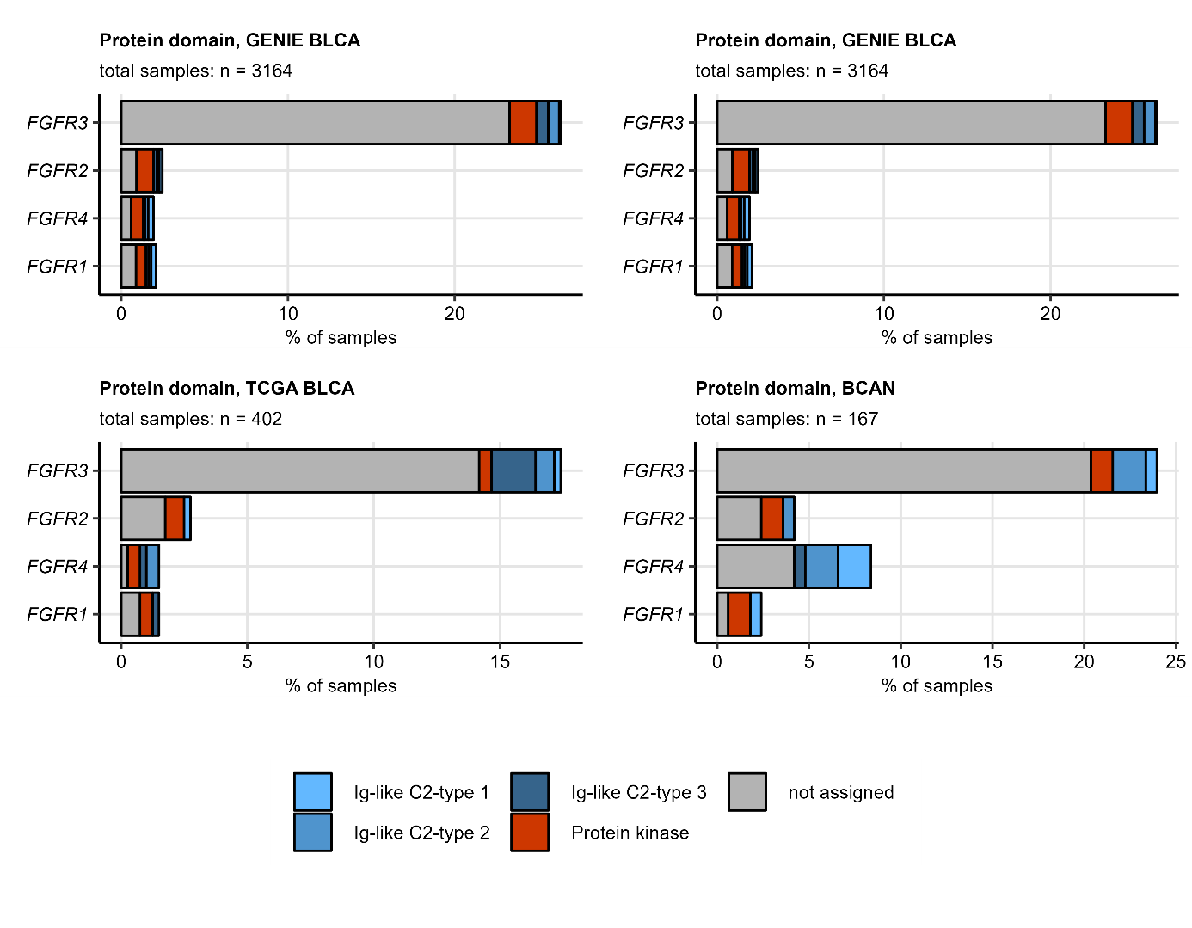

**Supplementary Figure 3 – Representative immunohistochemistry staining images for FGFR proteins retrieved from the Human Protein Atlas.** Images of immunohistochemistry (IHC) staining for FGFR, FGF, and FGFBP in urothelial cancer samples were retrieved from the Human Protein Atlas (HPA). The staining was quantified by the IHC score which was defined as a product of intensity (1: negative, 4: strong) and quantity of positive cells (1: none to 4: >75%). For each protein, representative images of immunohistochemistry (IHC) staining were selected; the left image corresponds to the minimum IHC score, the middle image shows the staining close to the median IHC score, the right image corresponds to the maximal IHC score. The images are labeled with HPA patient identifiers (ID) and IHC scores.

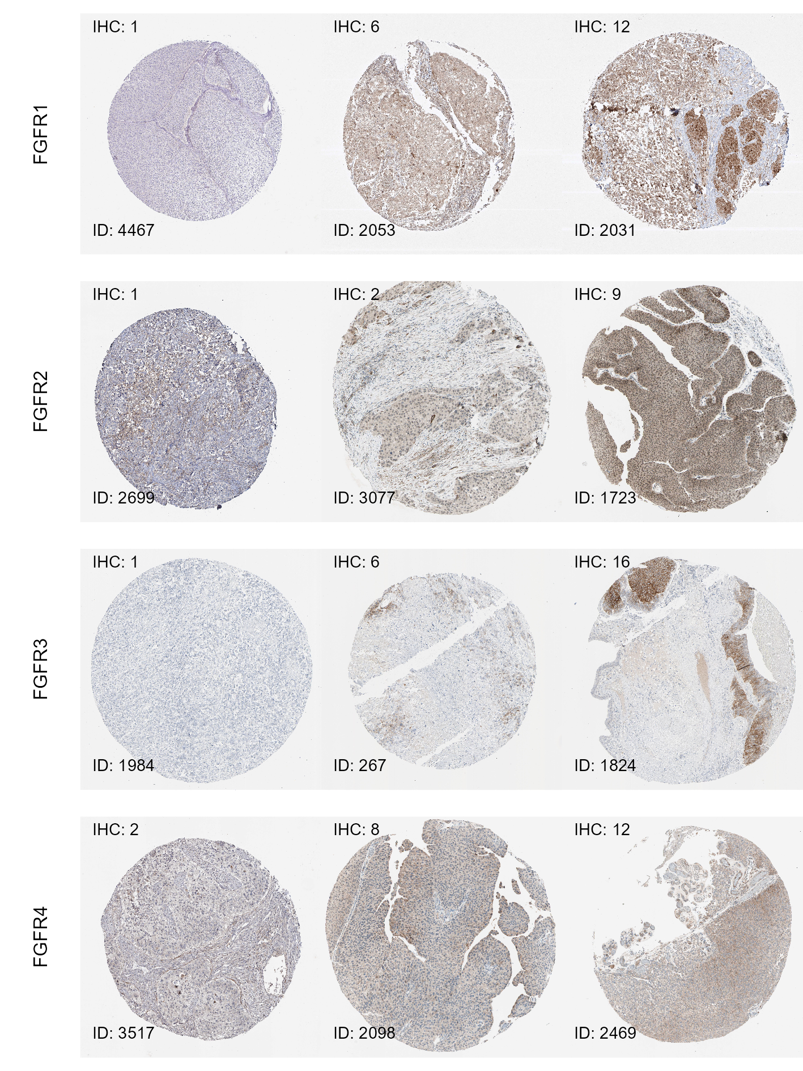

**Supplementary Figure 4 – Representative immunohistochemistry staining images for FGF proteins retrieved from the Human Protein Atlas.** Images of immunohistochemistry (IHC) staining for FGFR, FGF, and FGFBP in urothelial cancer samples were retrieved from the Human Protein Atlas (HPA). The staining was quantified by the IHC score which was defined as a product of intensity (1: negative, 4: strong) and quantity of positive cells (1: none to 4: >75%). For each protein, representative images of immunohistochemistry (IHC) staining were selected; the left image corresponds to the minimum IHC score, the middle image shows the staining close to the median IHC score, the right image corresponds to the maximal IHC score. The images are labeled with HPA patient identifiers (ID) and IHC scores.

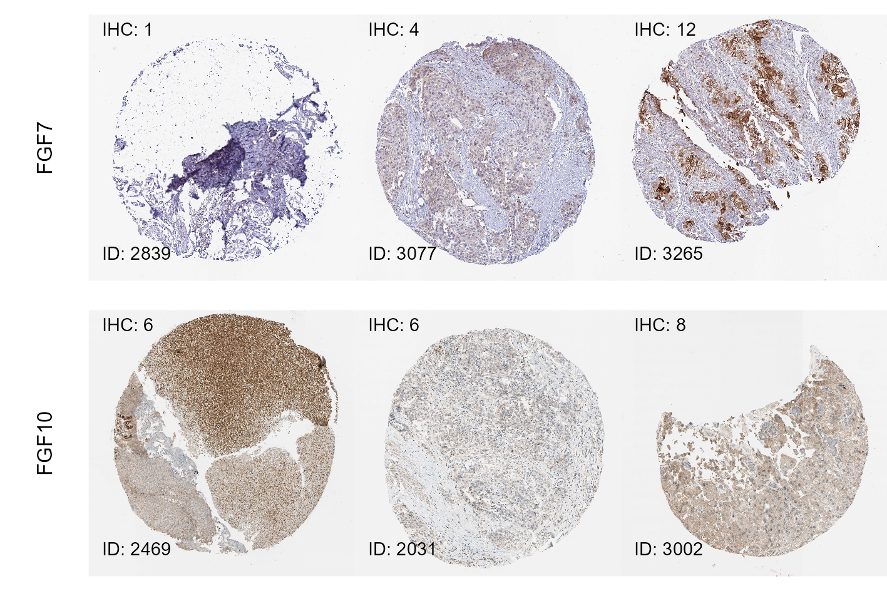

**Supplementary Figure 5 – Representative immunohistochemistry staining images for FGFBP proteins retrieved from the Human Protein Atlas.** Images of immunohistochemistry (IHC) staining for FGFR, FGF, and FGFBP in urothelial cancer samples were retrieved from the Human Protein Atlas (HPA). The staining was quantified by the IHC score which was defined as a product of intensity (1: negative, 4: strong) and quantity of positive cells (1: none to 4: >75%). For each protein, representative images of immunohistochemistry (IHC) staining were selected; the left image corresponds to the minimum IHC score, the middle image shows the staining close to the median IHC score, the right image corresponds to the maximal IHC score. The images are labeled with HPA patient identifiers (ID) and IHC scores.

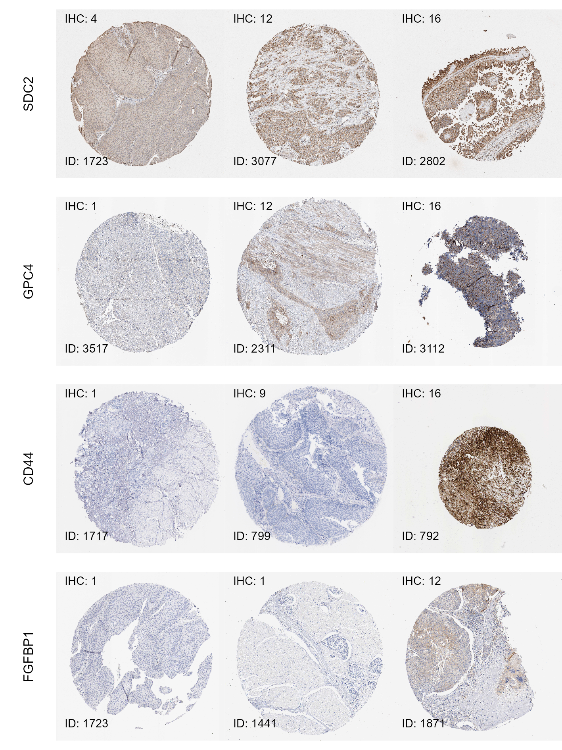

**Supplementary Figure 6 – Co-expression networks of FGF-, FGFR-, and FGFBP-coding genes: DepMap cell lines.** Co-expression network was constructed in the DepMap urothelial cancer cell line collection for the FGFR-, FGF-, and FGFBP-coding genes, whose expression levels correlated with Spearman’s rho $ρ≥$ 0.3. Isolated vertices of the networks were removed. Gene communities were identified with the Leiden algorithm and named after their FGFR-coding members. Candidate hub genes of the communities were selected by computing hub scores separately for each community (eigenvectors of the affinity matrix, i.e. metrics of the overall correlation strength). The networks were visualized using the Fruchterman-Reingold algorithm. Points represent node vertices/genes, point shape codes for classification of the protein product. Point color codes for the community assignment (A) or hub score (B). Lines represent edges, i.e. correlations between expression levels with $ρ≥$ 0.3. Line widths correspond to $ρ$ values. Note the central positions and high scores of the FGFR1, FGFR2, and FGFR3 genes and their assignment to the communities. This suggests exclusivity, i.e that FGFR1 with its ligands (FGF2, FGF5) and accessory molecules (CD44, TNFAIP6, FGFRL1) provide oncogenic signaling in a subset of cell lines, while signaling via FGFR2/FGFR3 and their co-receptors (GPC1/3, SDC1/4, HSPG2, TGFBR3) is exploited by another, non-overlapping cell line subset.

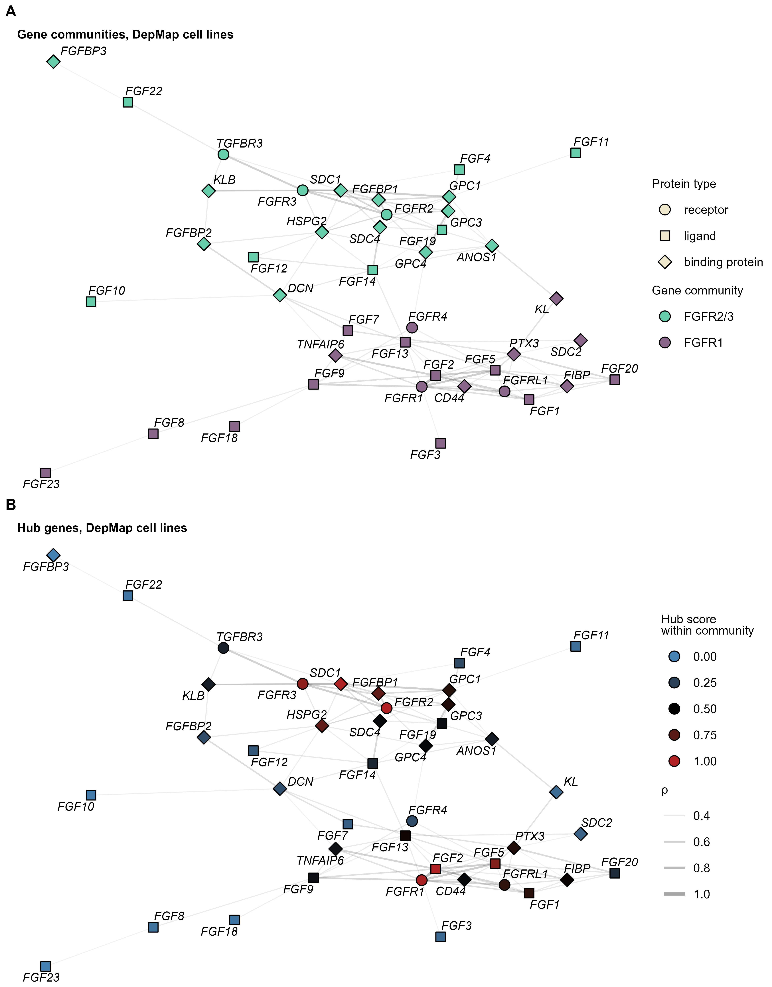

**Supplementary Figure 7** – **Differential expression of FGFR-, FGF-, and FGFR-coding genes in the consensus molecular classes of urothelial cancers.** Assignment of cancer samples from the IMvigor, and BCAN to the consensus molecular classes was presented in Figure 22. Differences in log2-transformed mRNA levels of FGFR-, FGF-, and FGFBP-coding genes between the consensus molecular classes were assessed by one-way ANOVA with $η^{2}$ effect size statistic. Differences in $log_{2}$-transformed gene expression between a subset and luminal papillary subset (LumP) were investigated by two-tailed T test. P values were corrected for multiple testing with the false discovery rate method (FDR). Significantly differentially regulated genes were defined by p(ANOVA) < 0.05, $η^{2}≥$ 0.06, pFDR(T test) < 0.05, and at least 1.25-fold up- or downregulation in a subset as compared with LumP cancers. Z-scores of $log_{2}$ expression levels of significantly differentially regulated genes shared by at least two cohorts are displayed in heat maps. Significant genes are labelled with bold font in the Y axes. Numbers of cancer samples in the consensus subtypes are indicated in the plot caption. Note: samples without reliable assignment to the consensus subtypes are not presented in the heat maps.

LumP: luminal papillary; LumU: luminal genetically unstable; LumNS: luminal non-specified; Stroma-rich: luminal stroma-rich; Ba/Sq: basal/squamous-like; NE-like: neuroendocrine-like

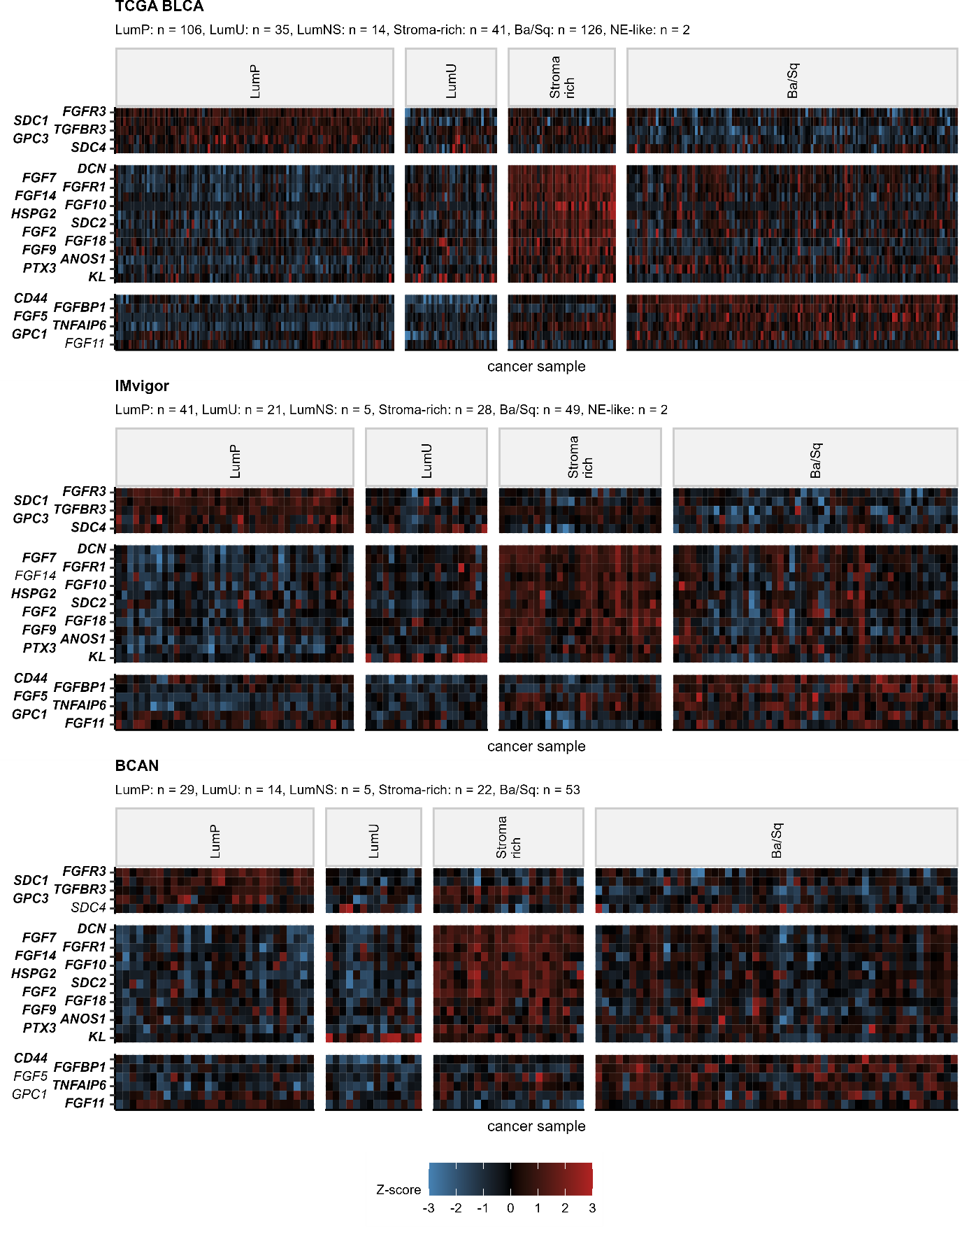

**References**

1. Wickham H, Averick M, Bryan J, Chang W, McGowan L, François R, Grolemund G, Hayes A, Henry L, Hester J, et al. Welcome to the Tidyverse. *Journal of Open Source Software* (2019) 4:1686. doi: [10.21105/joss.01686](https://doi.org/10.21105/joss.01686)

2. Henry L, Wickham Hadley. rlang: Functions for Base Types and Core R and ’Tidyverse’ Features. (2022) <https://cran.r-project.org/web/packages/rlang/index.html>

3. Gagolewski M, Tartanus B. Package ’stringi’. (2021) [https://cran.r-project.org/web/packages/stringi/index.html http://cran.ism.ac.jp/web/packages/stringi/stringi.pdf](https://cran.r-project.org/web/packages/stringi/index.html%20http://cran.ism.ac.jp/web/packages/stringi/stringi.pdf)

4. Wickham Hadley. *ggplot2: Elegant Graphics for Data Analysis*. 1st ed. New York: Springer-Verlag (2016). <https://ggplot2.tidyverse.org>

5. Wilke CO. *Fundamentals of Data Visualization: A Primer on Making Informative and Compelling Figures*. 1st ed. Sebastopol: O’Reilly Media (2019).

6. Gohel D. flextable: Functions for Tabular Reporting. (2022) <https://cran.r-project.org/web/packages/flextable/index.html>

7. Sweeney SM, Cerami E, Baras A, Pugh TJ, Schultz N, Stricker T, Lindsay J, Del Vecchio Fitz C, Kumari P, Micheel C, et al. AACR Project GENIE: Powering Precision Medicine through an International Consortium. *Cancer discovery* (2017) 7:818–831. doi: [10.1158/2159-8290.CD-17-0151](https://doi.org/10.1158/2159-8290.CD-17-0151)

8. Clinton TN, Chen Z, Wise H, Lenis AT, Chavan S, Donoghue MTA, Almassi N, Chu CE, Dason S, Rao P, et al. Genomic heterogeneity as a barrier to precision oncology in urothelial cancer. *Cell Reports* (2022) 41: doi: [10.1016/j.celrep.2022.111859](https://doi.org/10.1016/j.celrep.2022.111859)

9. Liu J, Lichtenberg T, Hoadley KA, Poisson LM, Lazar AJ, Cherniack AD, Kovatich AJ, Benz CC, Levine DA, Lee AV, et al. An Integrated TCGA Pan-Cancer Clinical Data Resource to Drive High-Quality Survival Outcome Analytics. *Cell* (2018) 173:400–416.e11. doi: [10.1016/J.CELL.2018.02.052](https://doi.org/10.1016/J.CELL.2018.02.052)

10. Robertson AG, Kim J, Al-Ahmadie H, Bellmunt J, Guo G, Cherniack AD, Hinoue T, Laird PW, Hoadley KA, Akbani R, et al. Comprehensive Molecular Characterization of Muscle-Invasive Bladder Cancer. *Cell* (2017) 171:540–556.e25. doi: [10.1016/J.CELL.2017.09.007](https://doi.org/10.1016/J.CELL.2017.09.007)

11. Balar AV, Galsky MD, Rosenberg JE, Powles T, Petrylak DP, Bellmunt J, Loriot Y, Necchi A, Hoffman-Censits J, Perez-Gracia JL, et al. Atezolizumab as first-line therapy in cisplatin-ineligible patients with locally advanced and metastatic urothelial carcinoma: a single-arm, multicentre, phase 2 trial. *Lancet (London, England)* (2017) 389:67. doi: [10.1016/S0140-6736(16)32455-2](https://doi.org/10.1016/S0140-6736(16)32455-2)

12. Damrauer JS, Beckabir W, Klomp J, Zhou M, Plimack ER, Galsky MD, Grivas P, Hahn NM, O’Donnell PH, Iyer G, et al. Collaborative study from the Bladder Cancer Advocacy Network for the genomic analysis of metastatic urothelial cancer. *Nature communications* (2022) 13: doi: [10.1038/S41467-022-33980-9](https://doi.org/10.1038/S41467-022-33980-9)

13. Whiting K. cbioportalR: R package to wrap cBioPortal’s API to pull data from public or private cBioPortal databases. (2024) <https://github.com/karissawhiting/cbioportalR>

14. Mariathasan S, Turley SJ, Nickles D, Castiglioni A, Yuen K, Wang Y, Kadel EE, Koeppen H, Astarita JL, Cubas R, et al. TGF $β$ attenuates tumour response to PD-L1 blockade by contributing to exclusion of T cells. *Nature 2018 554:7693* (2018) 554:544–548. doi: [10.1038/nature25501](https://doi.org/10.1038/nature25501)

15. Leek JT, Johnson WE, Parker HS, Jaffe AE, Storey JD. The sva package for removing batch effects and other unwanted variation in high-throughput experiments. *Bioinformatics* (2012) 28:882. doi: [10.1093/BIOINFORMATICS/BTS034](https://doi.org/10.1093/BIOINFORMATICS/BTS034)

16. Kamoun A, Reyniès A de, Allory Y, Sjödahl G, Robertson AG, Seiler R, Hoadley KA, Groeneveld CS, Al-Ahmadie H, Choi W, et al. A Consensus Molecular Classification of Muscle-invasive Bladder Cancer. *European urology* (2020) 77:420. doi: [10.1016/J.EURURO.2019.09.006](https://doi.org/10.1016/J.EURURO.2019.09.006)

17. Korc M, Friesel R. The Role of Fibroblast Growth Factors in Tumor Growth. *Current Cancer Drug Targets* (2009) 9: doi: [10.2174/156800909789057006](https://doi.org/10.2174/156800909789057006)

18. Turati M, Giacomini A, Rezzola S, Maccarinelli F, Gazzaroli G, Valentino S, Bottazzi B, Presta M, Ronca R. The natural FGF-trap long pentraxin 3 inhibits lymphangiogenesis and lymphatic dissemination. *Experimental hematology & oncology* (2022) 11: doi: [10.1186/S40164-022-00330-W](https://doi.org/10.1186/S40164-022-00330-W)

19. Bennett KL, Jackson DG, Simon JC, Tanczos E, Peach R, Modrell B, Stamenkovic I, Plowman G, Aruffo A. CD44 isoforms containing exon V3 are responsible for the presentation of heparin-binding growth factor. *The Journal of cell biology* (1995) 128:687–698. doi: [10.1083/JCB.128.4.687](https://doi.org/10.1083/JCB.128.4.687)

20. Gubbiotti MA, Vallet SD, Ricard-Blum S, Iozzo RV. Decorin interacting network: A comprehensive analysis of decorin-binding partners and their versatile functions. *Matrix biology : journal of the International Society for Matrix Biology* (2016) 55:7. doi: [10.1016/J.MATBIO.2016.09.009](https://doi.org/10.1016/J.MATBIO.2016.09.009)

21. Mundhenke C, Meyer K, Drew S, Friedl A. Heparan Sulfate Proteoglycans as Regulators of Fibroblast Growth Factor-2 Receptor Binding in Breast Carcinomas. *The American Journal of Pathology* (2002) 160:185. doi: [10.1016/S0002-9440(10)64362-3](https://doi.org/10.1016/S0002-9440(10)64362-3)

22. Midorikawa Y, Ishikawa S, Iwanari H, Imamura T, Sakamoto H, Miyazono K, Kodama T, Makuuchi M, Aburatani H. Glypican-3, overexpressed in hepatocellular carcinoma, modulates FGF2 and BMP-7 signaling. *International journal of cancer* (2003) 103:455–465. doi: [10.1002/IJC.10856](https://doi.org/10.1002/IJC.10856)

23. Leali D, Inforzato A, Ronca R, Bianchi R, Belleri M, Coltrini D, Di Salle E, Sironi M, Norata GD, Bottazzi B, et al. Long pentraxin 3/tumor necrosis factor-stimulated gene-6 interaction a biological rheostat for fibroblast growth factor 2-mediated angiogenesis. *Arteriosclerosis, Thrombosis, and Vascular Biology* (2012) 32:696–703. doi: [10.1161/ATVBAHA.111.243998/-/DC1](https://doi.org/10.1161/ATVBAHA.111.243998/-/DC1)

24. Xie Y, Su N, Yang J, Tan Q, Huang S, Jin M, Ni Z, Zhang B, Zhang D, Luo F, et al. FGF/FGFR signaling in health and disease. (2020) 5: doi: [10.1038/s41392-020-00222-7](https://doi.org/10.1038/s41392-020-00222-7)

25. Hagihara K, Watanabe K, Chun J, Yamaguchi Y. Glypican-4 is an FGF2-binding heparan sulfate proteoglycan expressed in neural precursor cells. *Developmental Dynamics* (2000) 219: doi: [10.1002/1097-0177(2000)9999:9999<::AID-DVDY1059>3.0.CO;2-#](https://doi.org/10.1002/1097-0177(2000)9999:9999%3c::AID-DVDY1059%3e3.0.CO;2-)

26. Pan J, Ho M. Role of glypican-1 in regulating multiple cellular signaling pathways. *American Journal of Physiology - Cell Physiology* (2021) 321:C846. doi: [10.1152/AJPCELL.00290.2021](https://doi.org/10.1152/AJPCELL.00290.2021)

27. Mohammadi M, Olsen SK, Ibrahimi OA. Structural basis for fibroblast growth factor receptor activation. *Cytokine & growth factor reviews* (2005) 16:107–137. doi: [10.1016/J.CYTOGFR.2005.01.008](https://doi.org/10.1016/J.CYTOGFR.2005.01.008)

28. Hu Y, Guimond SE, Travers P, Cadman S, Hohenester E, Tumbull JE, Kim SH, Bouloux PM. Novel mechanisms of fibroblast growth factor receptor 1 regulation by extracellular matrix protein anosmin-1. *The Journal of biological chemistry* (2009) 284:29905–29920. doi: [10.1074/JBC.M109.049155](https://doi.org/10.1074/JBC.M109.049155)

29. Ooms J. A Simple and Robust JSON Parser and Generator for R [R package jsonlite version 1.8.8]. (2023) <https://cran.r-project.org/package=jsonlite>

30. Wickham H, Hester J, Ooms J. xml2: Parse XML. (2023) doi: [10.32614/CRAN.PACKAGE.XML2](https://doi.org/10.32614/CRAN.PACKAGE.XML2)

31. DepMap. Current DepMap Release data, including CRISPR Screens, PRISM Drug Screens, Copy Number, Mutation, Expression, and Fusions. *Figshare+* (2024) Broad: doi: [10.25452/figshare.plus.25880521.v1](https://doi.org/10.25452/figshare.plus.25880521.v1)

32. McFarland JM, Ho ZV, Kugener G, Dempster JM, Montgomery PG, Bryan JG, Krill-Burger JM, Green TM, Vazquez F, Boehm JS, et al. Improved estimation of cancer dependencies from large-scale RNAi screens using model-based normalization and data integration. *Nature Communications 2018 9:1* (2018) 9:1–13. doi: [10.1038/s41467-018-06916-5](https://doi.org/10.1038/s41467-018-06916-5)

33. Dempster JM, Boyle I, Vazquez F, Root DE, Boehm JS, Hahn WC, Tsherniak A, McFarland JM. Chronos: a cell population dynamics model of CRISPR experiments that improves inference of gene fitness effects. *Genome Biology* (2021) 22:1–23. doi: [10.1186/S13059-021-02540-7/FIGURES/6](https://doi.org/10.1186/S13059-021-02540-7/FIGURES/6)

34. Yang W, Soares J, Greninger P, Edelman EJ, Lightfoot H, Forbes S, Bindal N, Beare D, Smith JA, Thompson IR, et al. Genomics of Drug Sensitivity in Cancer (GDSC): a resource for therapeutic biomarker discovery in cancer cells. *Nucleic Acids Research* (2013) 41:D955–D961. doi: [10.1093/NAR/GKS1111](https://doi.org/10.1093/NAR/GKS1111)

35. Yu C, Mannan AM, Yvone GM, Ross KN, Zhang YL, Marton MA, Taylor BR, Crenshaw A, Gould JZ, Tamayo P, et al. High-throughput identification of genotype-specific cancer vulnerabilities in mixtures of barcoded tumor cell lines. *Nature Biotechnology 2016 34:4* (2016) 34:419–423. doi: [10.1038/nbt.3460](https://doi.org/10.1038/nbt.3460)

36. Cohen J. Statistical Power Analysis for the Behavioral Sciences. *Statistical Power Analysis for the Behavioral Sciences* (2013) doi: [10.4324/9780203771587](https://doi.org/10.4324/9780203771587)

37. Benjamini Y, Hochberg Y. Controlling the False Discovery Rate: A Practical and Powerful Approach to Multiple Testing. *Journal of the Royal Statistical Society: Series B (Methodological)* (1995) 57:289–300. doi: [10.1111/j.2517-6161.1995.tb02031.x](https://doi.org/10.1111/j.2517-6161.1995.tb02031.x)

38. Mangiafico S. rcompanion: Functions to Support Extension Education Program Evaluation. (2022) <https://cran.r-project.org/package=rcompanion>

39. Kassambara A. rstatix: Pipe-Friendly Framework for Basic Statistical Tests. (2021) <https://cran.r-project.org/package=rstatix>

40. Chung NC, Miasojedow B, Startek M, Gambin A. jaccard: Test Similarity Between Binary Data using Jaccard/Tanimoto Coefficients. (2018) <https://cran.r-project.org/web/packages/jaccard/index.html>

41. Csardi G, Nepusz T. The igraph software package for complex network research. *InterJournal* (2006) Complex Sy:1695. <https://igraph.org>

42. Briatte F, Bojanowski M, Canouil M, Charlop-Powers Z, Fisher JC, Johnson K, Rinker T. ggnetwork: Geometries to Plot Networks with ’ggplot2’. (2021) <https://cran.r-project.org/package=ggnetwork>

43. Friedman J, Hastie T, Tibshirani R. Regularization paths for generalized linear models via coordinate descent. *Journal of Statistical Software* (2010) 33:1–22. doi: [10.18637/jss.v033.i01](https://doi.org/10.18637/jss.v033.i01)

44. Zou H, Hastie T. Regularization and variable selection via the elastic net. *Journal of the Royal Statistical Society Series B: Statistical Methodology* (2005) 67:301–320. doi: [10.1111/j.1467-9868.2005.00503.x](https://doi.org/10.1111/j.1467-9868.2005.00503.x)

45. Wright MN, Ziegler A. ranger: A Fast Implementation of Random Forests for High Dimensional Data in C++ and R. *Journal of Statistical Software* (2017) 77:1–17. doi: [10.18637/JSS.V077.I01](https://doi.org/10.18637/JSS.V077.I01)

46. Breiman L. Random forests. *Machine Learning* (2001) 45:5–32. doi: [10.1023/A:1010933404324](https://doi.org/10.1023/A:1010933404324)

47. Torgo L. An Infra-Structure for Performance Estimation and Experimental Comparison of Predictive Models in R. (2014) <https://arxiv.org/abs/1412.0436v4>

48. Chawla NV, Bowyer KW, Hall LO, Kegelmeyer WP. SMOTE: Synthetic Minority Over-sampling Technique. *Journal of Artificial Intelligence Research* (2002) 16:321–357. doi: [10.1613/JAIR.953](https://doi.org/10.1613/JAIR.953)

49. Torgo L. performanceEstimation: An Infra-Structure for Performance Estimation of Predictive Models. (2016) doi: [10.32614/CRAN.PACKAGE.PERFORMANCEESTIMATION](https://doi.org/10.32614/CRAN.PACKAGE.PERFORMANCEESTIMATION)

50. McHugh ML. Interrater reliability: the kappa statistic. *Biochemia Medica* (2012) 22:276. doi: [10.11613/bm.2012.031](https://doi.org/10.11613/bm.2012.031)

51. Brier GW. VERIFICATION OF FORECASTS EXPRESSED IN TERMS OF PROBABILITY. *Monthly Weather Review* (1950) 78:1–3. doi: [10.1175/1520-0493(1950)078<0001:vofeit>2.0.co;2](https://doi.org/10.1175/1520-0493(1950)078%3c0001:vofeit%3e2.0.co;2)

52. Goldstein-Greenwood J. A Brief on Brier Scores | UVA Library. (2021) <https://library.virginia.edu/data/articles/a-brief-on-brier-scores> [Accessed September 5, 2023]

53. Kuhn M. Building predictive models in R using the caret package. *Journal of Statistical Software* (2008) 28:1–26. doi: [10.18637/jss.v028.i05](https://doi.org/10.18637/jss.v028.i05)

54. Campo BDC. Towards reliable predictive analytics: a generalized calibration framework. (2023) doi: [10.48550/arXiv.2309.08559](https://doi.org/10.48550/arXiv.2309.08559)